 |  |  | 

Joint Programme Assessments 2022/23

Answer Sheet
(To be used in conjunction with the provided alternative assessment questions and the supplementary instructions)

Complete the information below about yourself very carefully.

QM student number
  2 | 0 | 0 | 9 | 7 | 8 | 9 | 4 | 7
BUPT student number
  2 | 0 | 2 | 0 | 2 | 1 | 3 | 2 | 4 | 8
Class number
  2 | 0 | 2 | 0 | 2 | 1 | 5 | 1 | 0 | 7

Module code
  EBU 6018
Word Count
  436

“I hereby confirm that the submitted work is entirely my own and I have not (i) used the services of any agency or person(s) providing specimen, model or ghostwritten work in the preparation of the work I submit for this open book assessment; (ii) given assistance in accessing this paper or in providing specimen, model or ghostwritten work to other candidates submitting for this open-book assessment.”
Signature
  Tangxun Wu

For examiners ONLY  Do not write in this section
   | Q1 | Q2 | Q3 | Q4 |  |  | Sum
  A
  B
  C
  D
  E
  F
  TOTAL

 | Do not write in this column
  Question | 1
  Section(s)
x = [-0.98, 1.11, -3.21, -1.31]
y = [1.27, 0.03, -2.39, 5.01]
so that the X:
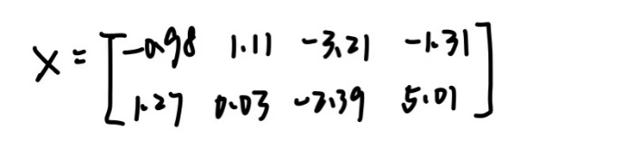
therefore, through the equation of mean vector:
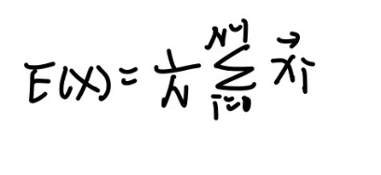
we can get E(x) = -1.0975, E(y) = 0.9800
so the mean vector of X:
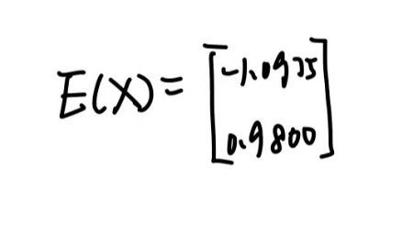
Then, we should find the covariance matrix.
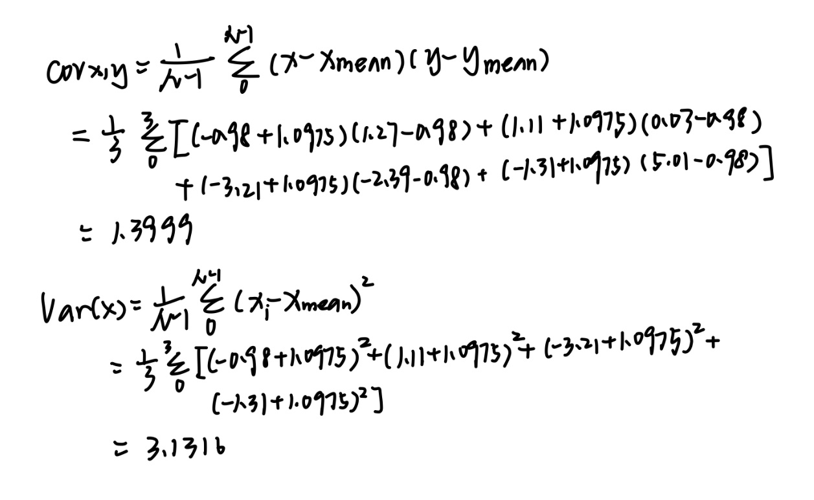

 | Do not write in this column
  Question | 1
  Section(s)
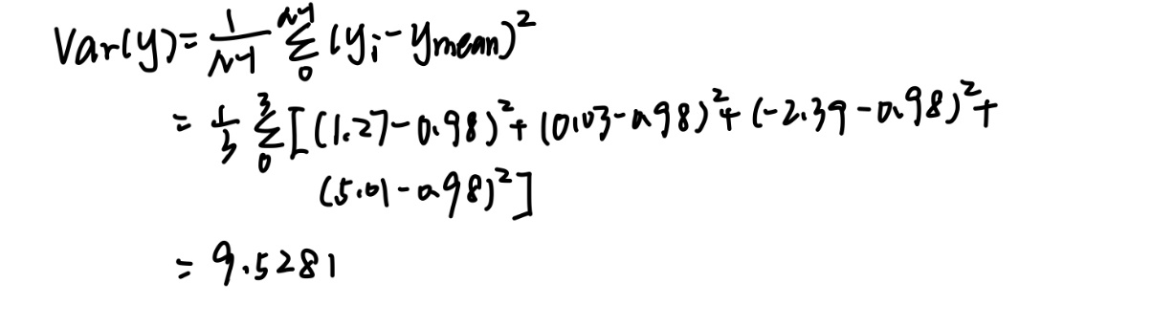
Through the values I get and the process of calculation,
I can get the following covariance matrix:
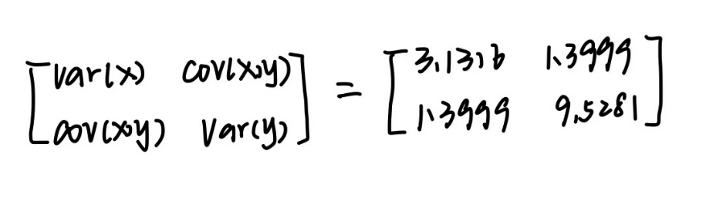

Over.

 | Do not write in this column
  Question | 2
  Section(s) | i)
From the question,
s[n] = [1.9, 1.2, 0.9, -0.9, -0.7, -0.8, 0.1, 1.6]
and we know that one expression of DCT[k] is:
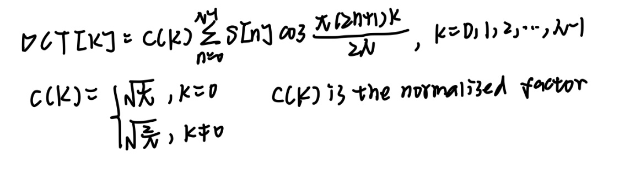
another expression of DCT[k] is:
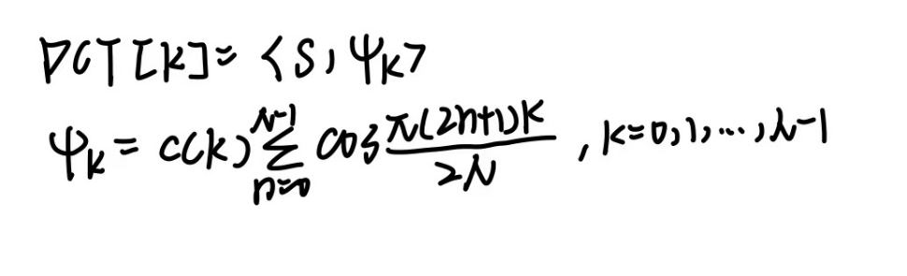
and from the book, we know that 8*8 DCT matrix is:
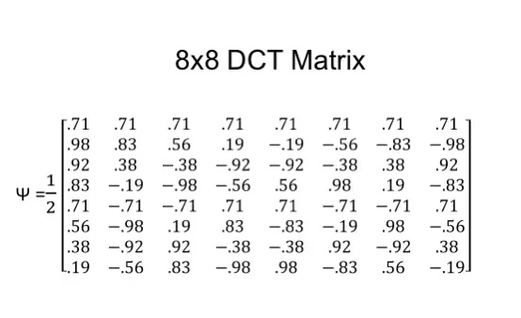
so the expression of DCT output sequence y[n]:

and the result is:
y[n] = [1.1667, 1.0572, 2.5855, -0.7607, 0.1768, -0.3734, 0.4215, 0.5285]

 | Do not write in this column
  Question | 2
  Section(s) | ii)
y[n] = [1.1667, 1.0572, 2.5855, -0.7607, 0.1768, -0.3734, 0.4215, 0.5285]
1. we know that the first output can tell us about the mean value.
So, the mean value of the sequence is 1.1667 divided by sqrt(N)
We get the result: mean value = 0.41249

2. from the output y[n], the third element is very big, this shows that there is a high correlation between the input data and the third row of the transform matrix.

3. the input data has a relatively large variation, and it has a relatively fast rate of change in values, which can be proved by the change from positive value to negative value in the sequence s[n].
